Joel Lantigua

Linux Administrator

Controlling Daemons

11/17/22

How to control daemons that run on boot

Daemons are programs that run silently in the background, some daemons can be ran right when the server boots up. The first thing I did was switched into root by using **su – root**. Next, to see a list of daemons and services that are running on your server I use the command **systemctl | grep daemon** and this will show you any active daemons. You can also disable and enable these daemons by using **systemctl stop [daemons name]** this stops the daemon from running as you can see below in the screenshots and if you want it to run you would use **systemctl start [daemons name]** and this will allow any services or daemons to run.

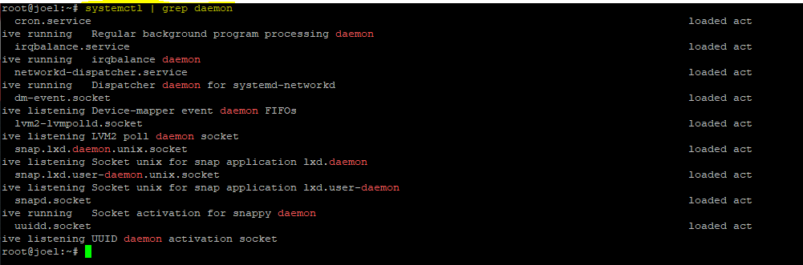

This screenshot below shows UUID.socket daemon running

This screenshot below shows how to stop a running daemon by using **systemctl stop [daemon name]** 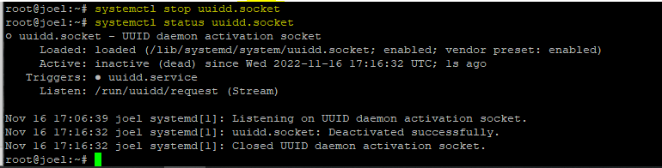

CentOS Daemon

To check running daemons on my CentOS server I used the same commands as my ubuntu server above. I used **systemctl | grep daemon** to see the running daemons. If I want to start a daemon, I can use the command **systemctl start [daemons name]**  and if I want to stop a daemon I can use the command **systemctl stop [daemons name].**  The commands are the same as my ubuntu server.

Work Cited

<https://www.digitalocean.com/community/tutorials/how-to-use-systemctl-to-manage-systemd-services-and-units>